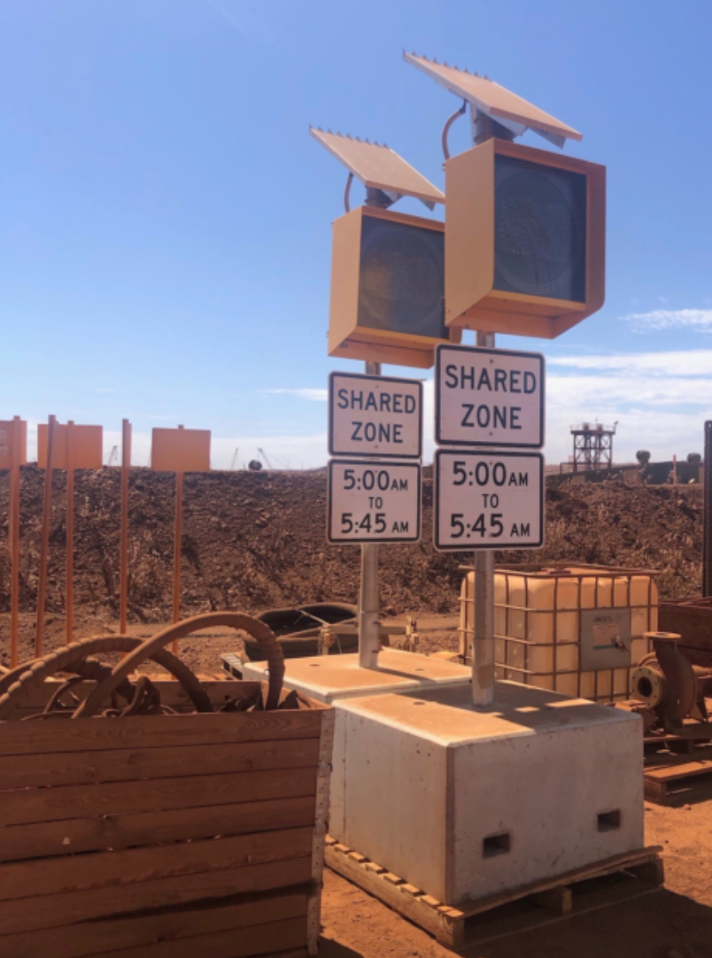

**STOp – Solar Traffic Operation**

**SPEED SIGN**

**OUR MISSION**

To inspire companies to choose a healthier, greener option through solar powered equipment. This is the beginning of innovative measures we have undertaken since 2017 by connecting the precast concrete industry with mechanical, electrical and carbon neutral solar industries. Our aim is to compliment low site interface requirements utilising the upper end of hazard management within the hierarchy of hazard control. By eliminating, substituting and engineering out.

**PURPOSE**

STOp – LIGHT POLE is an innovation that removes the requirement of underground power, insitu concrete foundations and reducing risk on site by reducing man hours through the construction process.

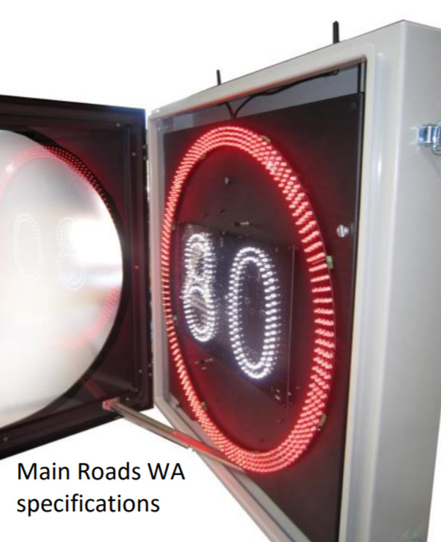

**DESIGN FEATURES**

**Stable precast concrete base** – sizes start from 1000mm x 1000mm x 600mm in height, all bases come with galvanised fork tine recesses, that are centrally positioned, offering positive retention while offloading and moving over uneven ground to their location for installation.

**AD303 Electronic Speed Limit Signs (ESLS) -** are highly visible and innovative, creating instant awareness of different speed limits to passing traffic.

The Electronic Speed Limit signs that we produce feature an ultra-bright, high quality and long-life LED technology which can display up to 3 different speed limits from 10 to 110kph in increments of 10 or 5. It can be remotely controlled, and it is manufactured as mains or fully solar powered for 24/7 operation.

Low maintenance, superior reliability, power efficiency and easy installation make our electronic speed limit signs the ideal choice for Australia’s harsh environmental conditions. It is available in the Australian standard types A, B, C & D sizes and we can customise it to meet any road authority requirements.

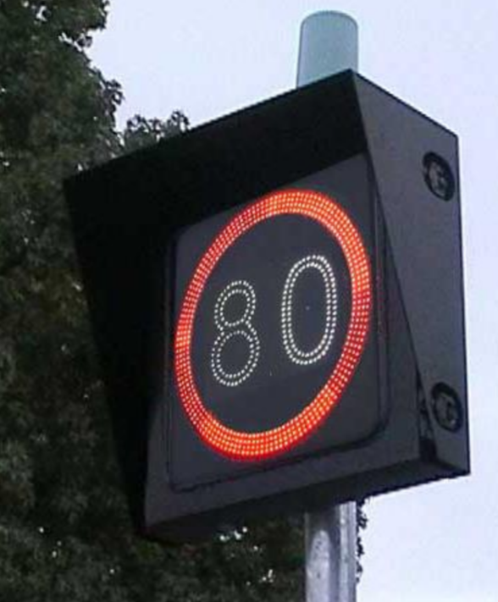

Features

* Ultra-bright, weatherproof and vandal resistant LED display
* Display up to 3 different speed limits from 10 to 110kph
* 4 rows of programmable flashing annulus in red
* Automatic brightness adjustment
* Time & date scheduled change times
* Local & remote (optional) programming
* Very long service life
* Synchronised flashing of annulus in Master / Slave pairs
* High quality powder coated aluminium enclosure
* Lockable & secure enclosure
* Impact resistant polycarbonate screen
* Easy installation & low maintenance requirements
* Conforms to road authority requirements
* Facility key switch for Road Workers / Police / Emergency Services

**Solar Panel** – 40w solar system, 24 hour long-life LED technology illumination

**Signage** – signs are custom made suitable for site conditions.

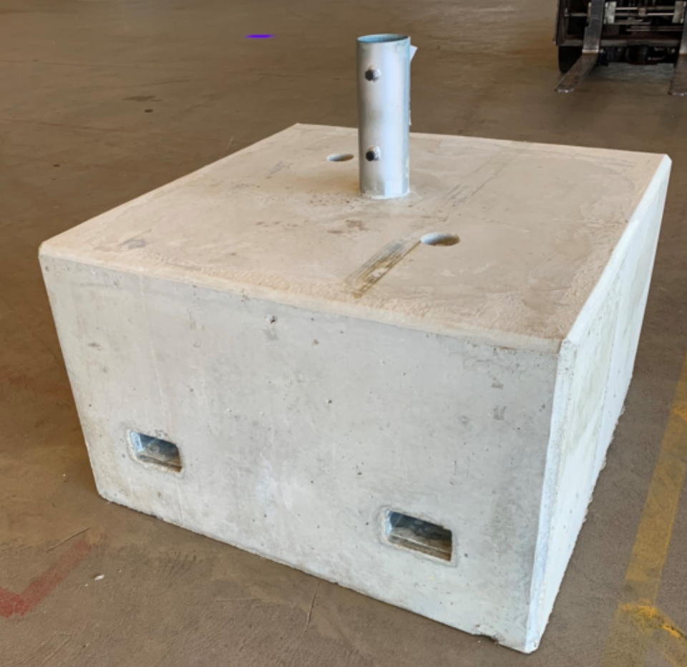

**Mounting Pole** – Sturdy 80mm NB galvanised post. The control panel is powder coated and easy to access for programming and battery maintenance.

SITE SPECIFIC DESIGN

Municipalities –

Mining Sector – optional light fittings

Security – optional camera

3D modelling for project specific requirements

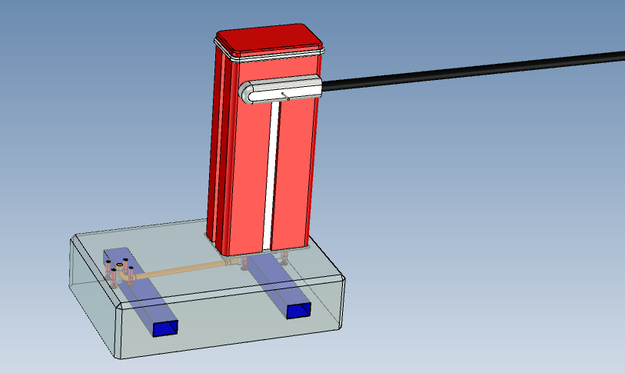

LIMITED WARRENTY

Precast Base – 10 years

AD303 ESLS – xx years

Pole – 10 years

Solar Panel – xx years

Battery – xx years

CONTACT US

E: [admin@aus-precast.com.au](mailto:admin@aus-precast.com.au)

W: [www.aus-precast.com.au](http://www.aus-precast.com.au)

P: (08) 9523 2555