

SkidCreteTM - Modular

Patent 2019100619

Aus-precast and Raine Consulting have been working closely together in the research and the development of an innovative new product, purpose build for the mining sector. This is just the beginning of innovative measures we are undertaking within the precast concrete industry. Our aim is to compliment low site interface requirements utilising the upper end of hazard management within the hierarchy of hazard control. By eliminating, substituting and engineering out, we have patented and developed an industry leading product that surpasses current technologies.

Purpose

SkidCrete is an innovation that removes redundant structural steel from a wide range of mechanical equipment skids that house or populate process equipment utilised in a wide array of mining, process, food, fluid management and allied industries. Traditionally equipment is built on skids to allow higher levels of completion and for fabrication and testing to be conducted in metropolitan areas where there is a greater access to skilled labour, manufacturing and engineering resources. Conventionally this equipment has been built of structural steel skid and transported to site for installation on insitu concrete. Thus, the role of the structural steel is redundant once the system gets to site. SkidCrete leverages the wide range of tilt panel technologies coupled with Commercial of the Shelf components (COTS) to realise a functionally equivalent monolithic concrete skid that is fabricated off-site, eliminating most of the structural steel with significant cost advantage.

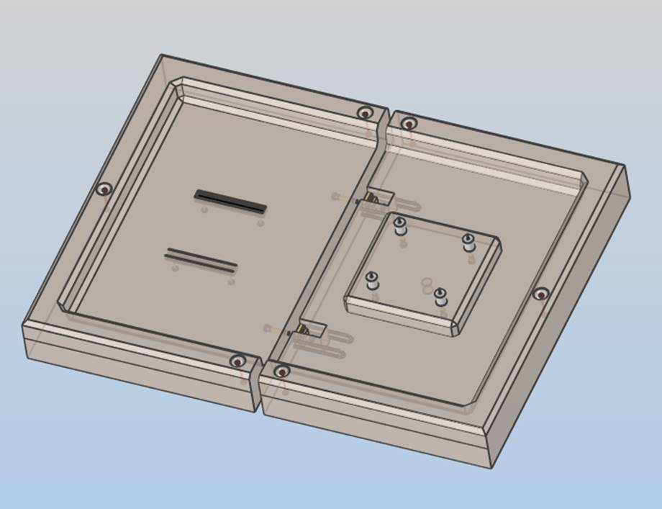

Design Features

**Ferrule Threaded Anchor** – The primary device for securing a wide array of process equipment.

**Cast in Channel** – Cast in Channel provides flexibility for freedom of movement for items in the skids

**Lifting Anchor** – Precertified with a WLL standardised load range.

**Post Tensioning** – Large equipment footprints require multiple substrates for logistical reasons. We have a post tensioning method, with guarantee of seal.

**Electrical, Earthing and Instrument Feeds** – Flush fit, bell end electrical conduit is installed for mechanical footprint requirements.

**Motor Mounts** – Equipment operating rotational systems require Motor Mounts to absorb destructive frequencies from variable speed drives.

**Survey Markers** – The skids will be equipped with Survey Markers that will represent set-out points for each skid.

Components

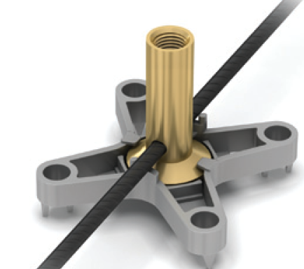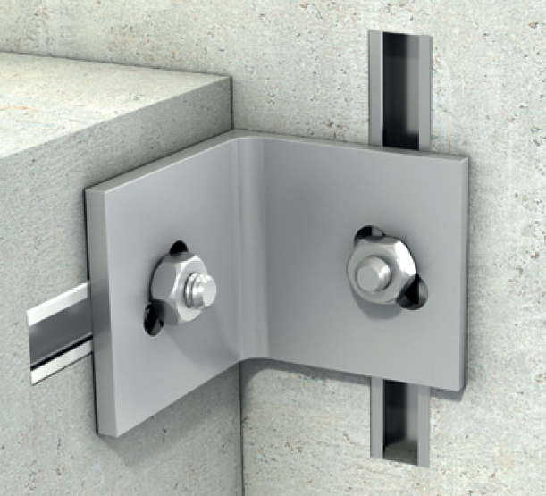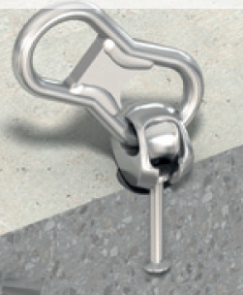

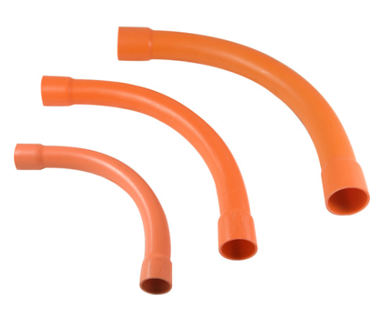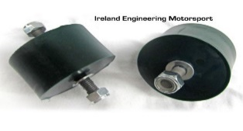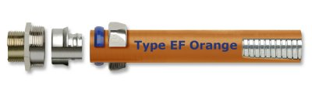

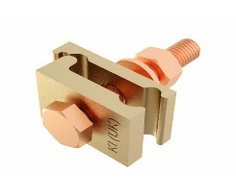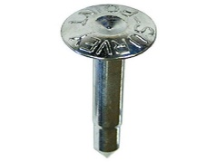

Contact Us

E: [admin@aus-precast.com.au](mailto:admin@aus-precast.com.au)

W: [www.aus-precast.com.au](http://www.aus-precast.com.au)

P: **(08) 9523 2555** 